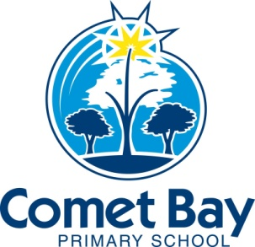
Comet Bay Primary School P&C Association
c/-85 Miltona Drive, Secret Harbour Western Australia 6173

COMET BAY PRIMARY SCHOOL
PARENTS AND CITIZENS’ ASSOCIATION INC.
OPEN ANNUAL GENERAL MEETING
MEETING TO START PROMPT AT 7.00 P.M., 7/3/17
AGENDA

7.00pm
1.) Open and Welcome by Chairperson (Cassie Levitzke, P&C President):
- Overview of meeting Structure
- Reminder of ‘Tribes’ Agreement as basis of Comet Bay Primary School:
- Attentive Listening
- Appreciation/No put-downs
- Mutual Respect
- The Right to Pass

2.) Attending members noted

3.) Apologies for Absence

4.) Confirmation of Minutes of Previous Meeting:

- The minutes of the P&C Open General Meeting of Comet Bay Primary School held on 1st March 2016 have been made available for public perusal, have been read and confirmed as an accurate and true record, and a copy has been put in the school file.

5) Confirmation of 2016 Financial Audit

7.05p.m.
6.) Election of Committee

President
Vice President
Secretary
Treasurer
Executive Committee Members

Disco Co-Ordinator
Donations/Recruitment Co-ordinator
Book Fair/ Book club Co-ordinator
Kiss & Drive Co-ordinator
Fuel Our School Co-Ordinator
Safety House Co-ordinator
SAKG Co-ordinator

Close AGM and continue with a normal meeting

7.) Confirmation of Minutes of Previous Meeting:
- The minutes of the P&C General Meeting of Comet Bay Primary School held on the 14th February 2017 have been made available for public perusal. They have been read and confirmed as an accurate and true record, and a copy has been put in the school file.

8.) Correspondence In/Out (Secretary):
- Business arising from correspondence:
- Outgoing Correspondence

9.) Updates:
- Canteen and online Canteen – Amanda Ball
- Uniform Shop – Sarah Groves.
- Principal – Graeme Watson
- School Board – Cass Levitzke
- Treasurer Report – Alisa Merrriman

10.) General Business

- Happy Walk
- Golf Day
- Facebook Page

NEXT MEETING – Tuesday 11th April

